**Test cases**

|  |
| --- |
| **Test case id:** 1  **Test case name:** Reading server configuration file |

|  |
| --- |
| **Pre-conditions:**  Server conf file must be present in project_home/runtime/ring |

|  |  |  |  |  |
| --- | --- | --- | --- | --- |
| **Step** | **Action** | **Expected Output** | **Actual Output** | **Pass/Fail** |
| 1 | Execute testReadingConfFile from JUnit test case suite | Required fields like port, management port, adjacent node details etc. must be present and must match the values specified in test case | Server configuration file contains all the required fields | Pass |

|  |
| --- |
| **Post-conditions:**  NA |

|  |
| --- |
| **Test case id:** 2  **Test case name:** Server basic configuration test |

|  |
| --- |
| **Pre-conditions:**  NA |

|  |  |  |  |  |
| --- | --- | --- | --- | --- |
| **Step** | **Action** | **Expected Output** | **Actual Output** | **Pass/Fail** |
| 1 | Execute testBasicConf from JUnit test case suite | Required server configuration details must be present | All required server configuration details are present | Pass |

|  |
| --- |
| **Post-conditions:**  NA |

|  |
| --- |
| **Test case id:** 3  **Test case name:** Server response format test |

|  |
| --- |
| **Pre-conditions:**  NA |

|  |  |  |  |  |
| --- | --- | --- | --- | --- |
| **Step** | **Action** | **Expected Output** | **Actual Output** | **Pass/Fail** |
| 1 | Execute testResponseFormat from JUnit test case suite | Required fields like response flag must be present.  If response type is success then it must contain name of file, uuid, data etc. | All required fields are present in response | Pass |

|  |
| --- |
| **Post-conditions:**  NA |

|  |
| --- |
| **Test case id:** 4  **Test case name:** To check format of forward request to another cluster |

|  |
| --- |
| **Pre-conditions:**  NA |

|  |  |  |  |  |
| --- | --- | --- | --- | --- |
| **Step** | **Action** | **Expected Output** | **Actual Output** | **Pass/Fail** |
| 1 | Execute testForwardToClusterRequestFormat from JUnit test case suite | Required fields like all fields from original request as well as entry node must be present | All required fields are present in forward request | Pass |

|  |
| --- |
| **Post-conditions:**  NA |

|  |
| --- |
| **Test case id:** 5  **Test case name:** Load test: Insert 1000 images |

|  |
| --- |
| **Pre-conditions:**  All servers must be running |

|  |  |  |  |  |
| --- | --- | --- | --- | --- |
| **Step** | **Action** | **Expected Output** | **Actual Output** | **Pass/Fail** |
| 1 | Execute load-test.py from project_home/python folder | Server should handle 1000 requests without crashing | Server properly handled 1000 requests | Pass |

|  |
| --- |
| **Post-conditions:**  NA |

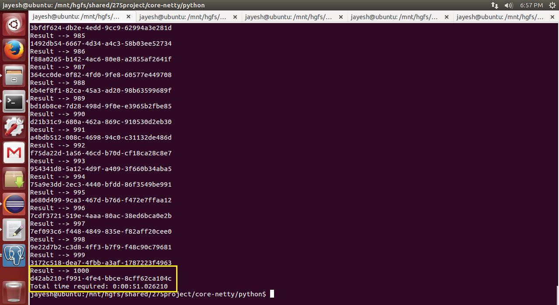

Python client snapshot displaying successful insertion of 1000 images and total time required which is approx. 51 seconds

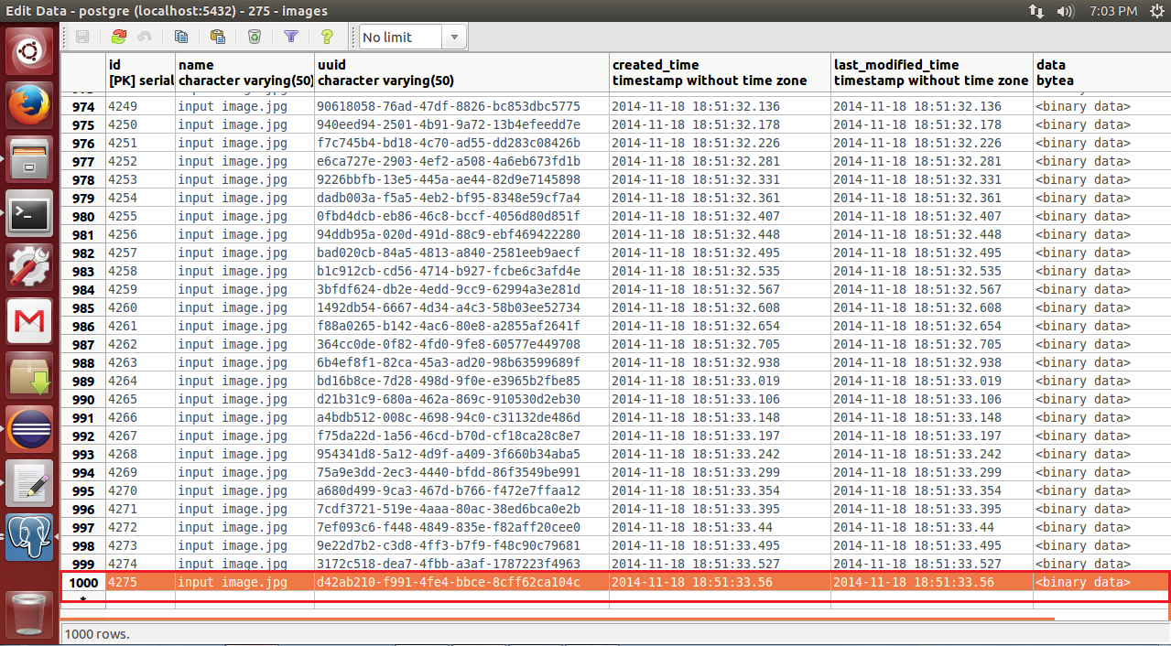

Database snapshot displaying successful insertion of 1000 images

|  |
| --- |
| **Test case id:** 6  **Test case name:** Test image delete |

|  |
| --- |
| **Pre-conditions:**  All servers should be running. Specify appropriate UUID in 275-client.py. |

|  |  |  |  |  |
| --- | --- | --- | --- | --- |
| **Step** | **Action** | **Expected Output** | **Actual Output** | **Pass/Fail** |
| 1 | Execute delete operation 275-client.py from project_home/python folder | Image should get deleted | Image deleted successfully | Pass |

|  |
| --- |
| **Post-conditions:**  NA |

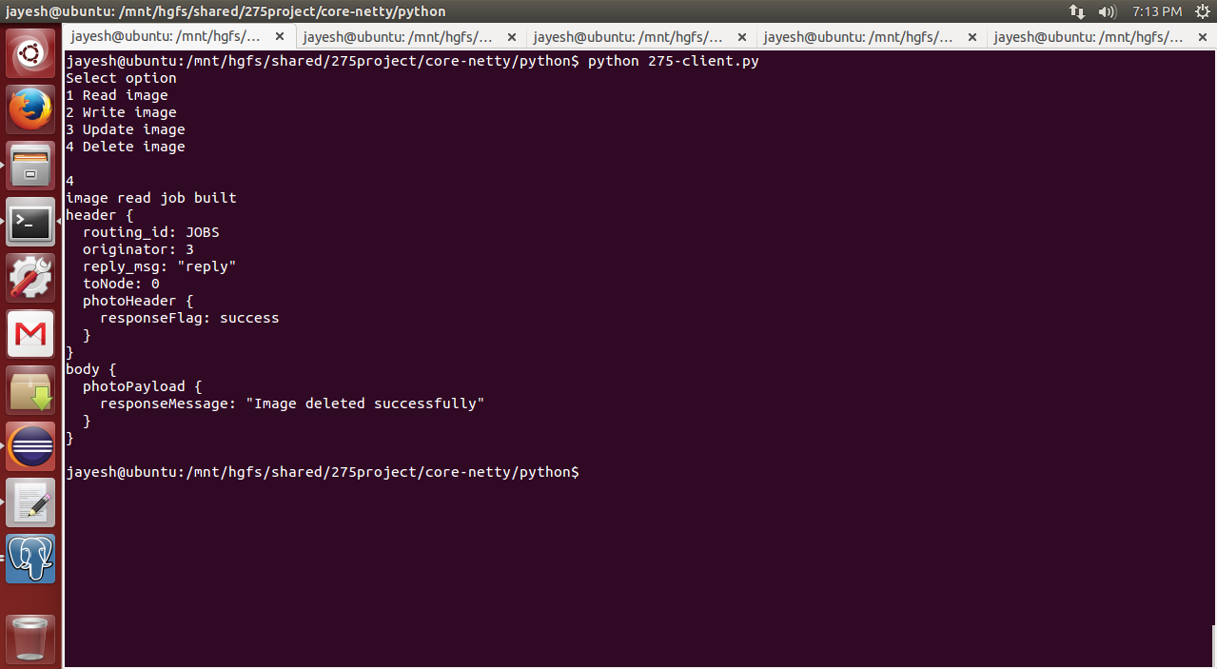

Image deleted successfully

|  |
| --- |
| **Test case id:** 7  **Test case name:** Test image delete when image not present |

|  |
| --- |
| **Pre-conditions:**  All servers should be running. Specify UUID (which is not present in images table) in 275-client.py. |

|  |  |  |  |  |
| --- | --- | --- | --- | --- |
| **Step** | **Action** | **Expected Output** | **Actual Output** | **Pass/Fail** |
| 1 | Execute delete operation 275-client.py from project_home/python folder | Appropriate error message and response flag failure should get displayed | “Image not found” message and “failure” status is displayed | Pass |

|  |
| --- |
| **Post-conditions:**  NA |

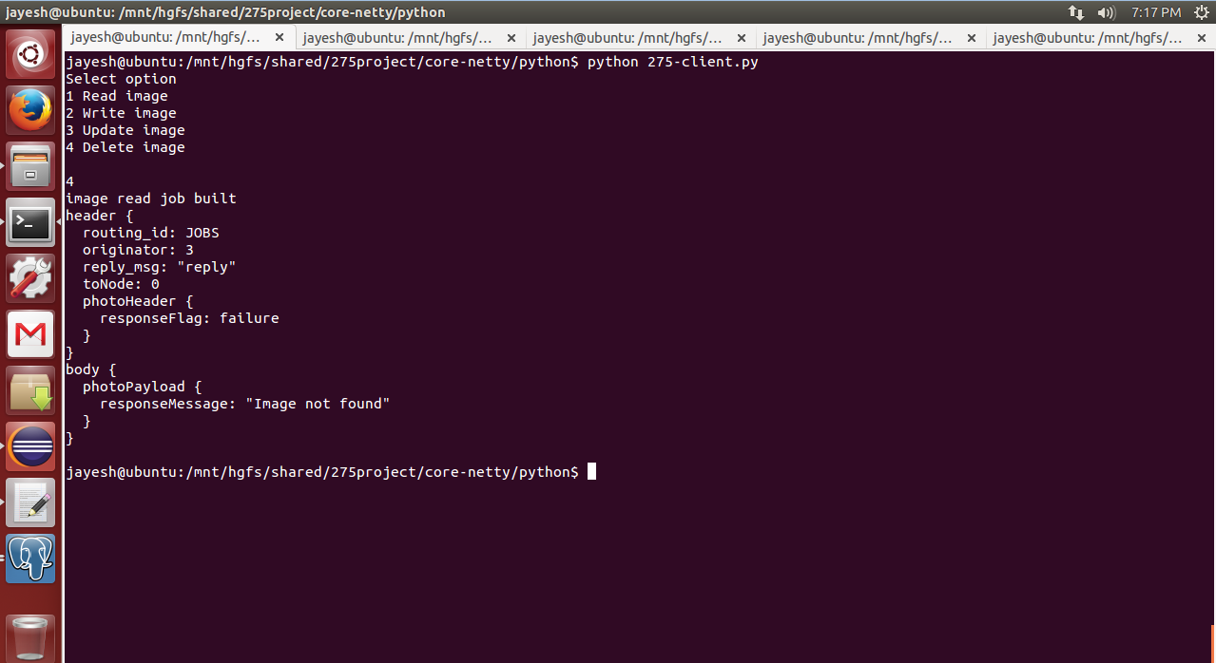

Image not present in database

|  |
| --- |
| **Test case id:** 8  **Test case name:** Test image read |

|  |
| --- |
| **Pre-conditions:**  All servers should be running. Specify appropriate UUID in 275-client.py. |

|  |  |  |  |  |
| --- | --- | --- | --- | --- |
| **Step** | **Action** | **Expected Output** | **Actual Output** | **Pass/Fail** |
| 1 | Execute read operation from 275-client.py from project_home/python folder | Image should be read successfully | Image read successfully | Pass |

|  |
| --- |
| **Post-conditions:**  NA |

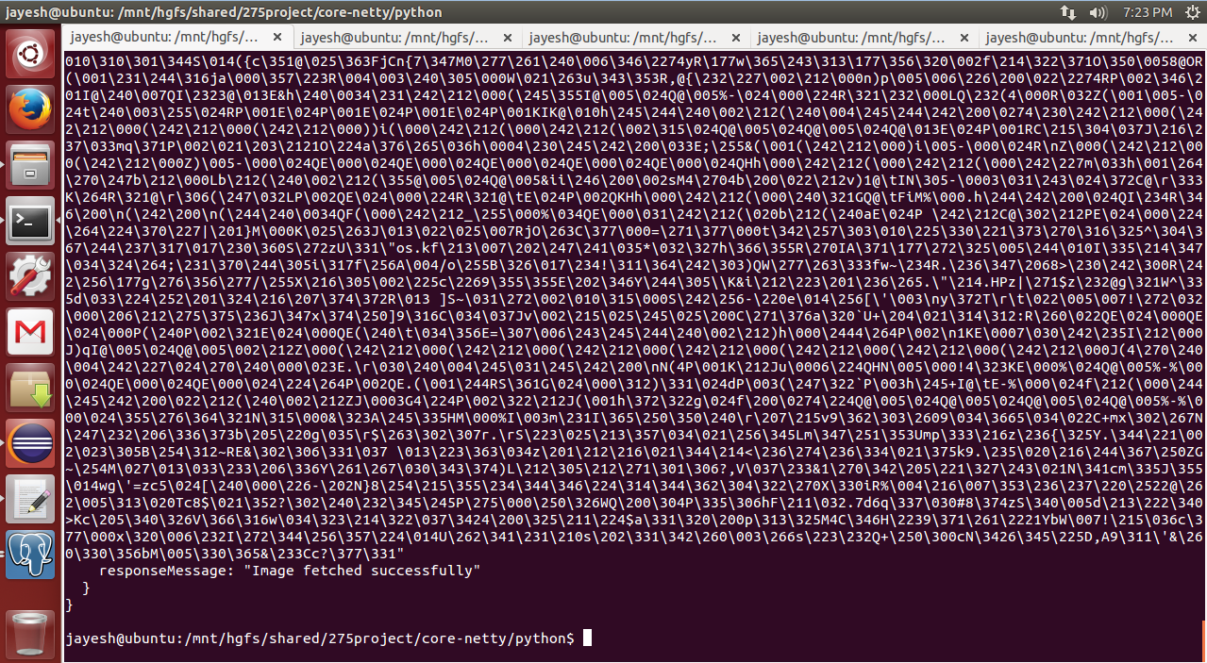

Image byte array returned after execution of read operation

|  |
| --- |
| **Test case id:** 9  **Test case name:** Test image read when image not present |

|  |
| --- |
| **Pre-conditions:**  All servers should be running. Specify UUID (which is not present in images table) in 275-client.py. |

|  |  |  |  |  |
| --- | --- | --- | --- | --- |
| **Step** | **Action** | **Expected Output** | **Actual Output** | **Pass/Fail** |
| 1 | Execute read operation from 275-client.py from project_home/python folder | Appropriate error message and response flag failure should get displayed | “Image not found” message and “failure” status is displayed | Pass |

|  |
| --- |
| **Post-conditions:**  NA |

|  |
| --- |
| **Test case id:** 10  **Test case name:** Test image update |

|  |
| --- |
| **Pre-conditions:**  All servers should be running. Specify appropriate UUID in 275-client.py. |

|  |  |  |  |  |
| --- | --- | --- | --- | --- |
| **Step** | **Action** | **Expected Output** | **Actual Output** | **Pass/Fail** |
| 1 | Execute update operation from 275-client.py from project_home/python folder | Image should get updated successfully | Image updated successfully | Pass |

|  |
| --- |
| **Post-conditions:**  NA |

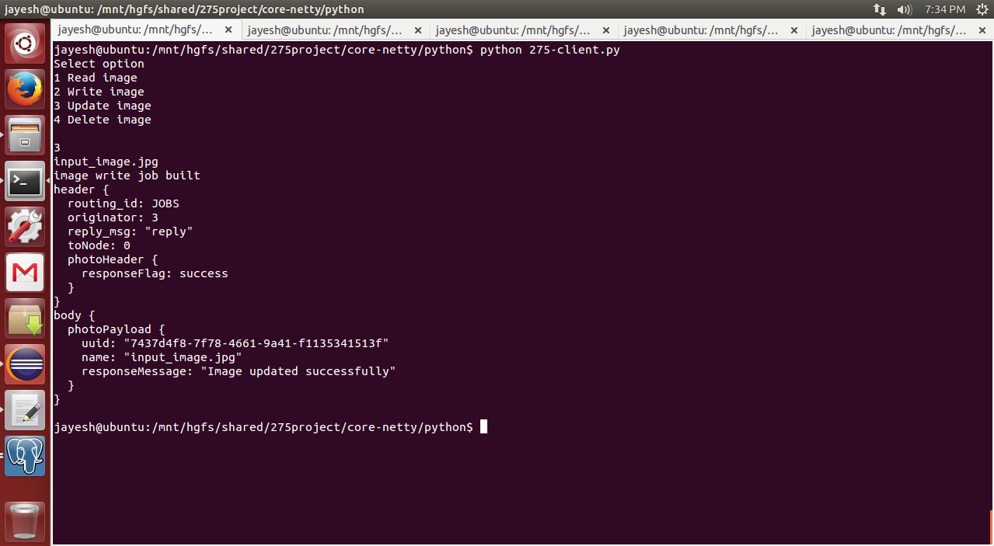

Response message showing image updated successfully

|  |
| --- |
| **Test case id:** 11  **Test case name:** Test image update when image not present |

|  |
| --- |
| **Pre-conditions:**  All servers should be running. Specify UUID (which is not present in images table) in 275-client.py. |

|  |  |  |  |  |
| --- | --- | --- | --- | --- |
| **Step** | **Action** | **Expected Output** | **Actual Output** | **Pass/Fail** |
| 1 | Execute update operation from 275-client.py from project_home/python folder | Appropriate error message and response flag failure should get displayed | “Image not found” message and “failure” status is displayed | Pass |

|  |
| --- |
| **Post-conditions:**  NA |